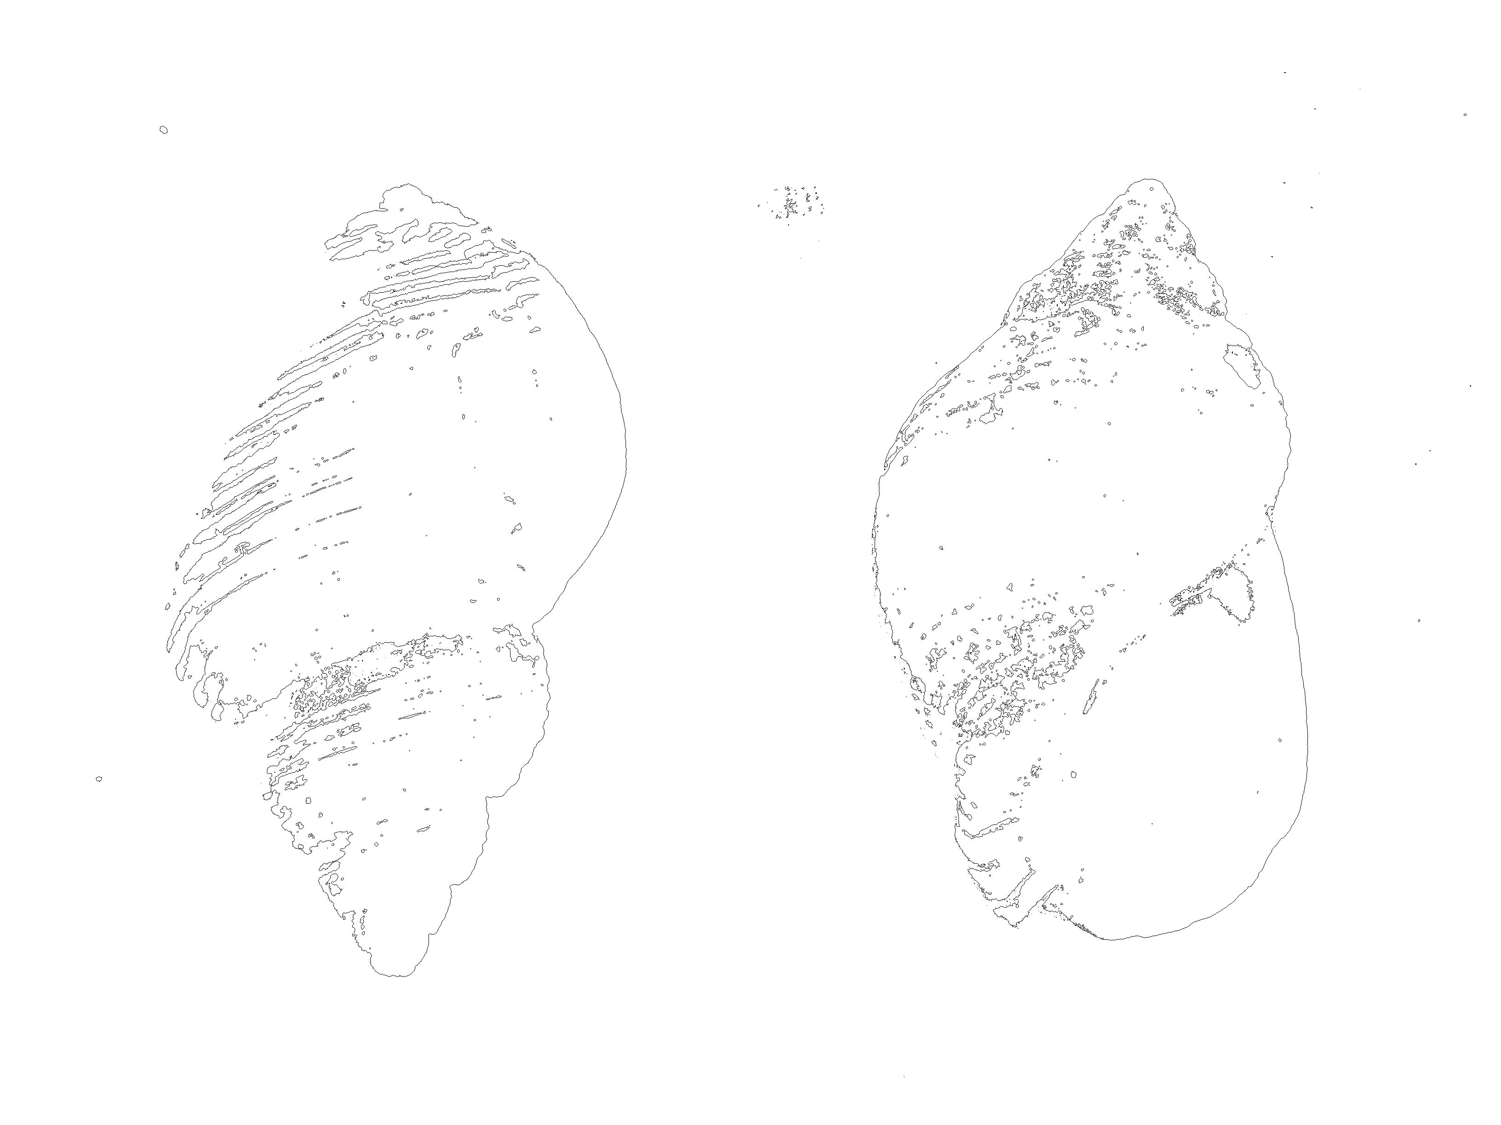
Shelling Out

Press Release

Conchlymania or ‘shell-lunacy’ in the 17th century referred to the hysteria around collecting, acquiring and dealing these ‘works of art from God’. It pinpoints the turning of the tide when things that were once child's playthings on the beach came to have the price of jewels.

Collections became declarations of wealth and faith (the gathering of shells on the beach coffered spiritual status) and the collectors themselves had surprising similarities to dealers and collectors of fine art today- both caring passionately for the status of possessing something strange and unusual from a distant land, preferably before anyone else.

Seashells are naturally occurring and no two shells are ever alike.

Presented inside this parallel universe are two areas, one Production and one Display. Using seashells and their complex and once extremely coveted natural beauty and mythology as a metaphor, it confronts how we consider value and originality today.

It is up to you to decide on the origins and meaning of these shells and ultimately, if they have worth.

Numbered and available to buy in sets of two – which will you chose?

£150 a set

Each created in an edition of 10.
Matching Perspex boxes, cotton inner, paper label.
Emma Gibson 2015.

About the Artist

Emma Gibson (b1980, UK) is a British artist working primarily in installation. Investigations into how each of us constructs our own reality and the bigger questions about what’s real versus what’s true are constantly moving goal posts in her multimedia work. A broad range of influences include both neuroscience and theoretical physics, stemming from finding a hidden room full of undecipherable codes written by her late granddad, at his home after his death – as yet unbroken.

Egibson.co.uk

#ShellingOut

twitter @emma__gibson
instagram @gibson.emma

